

**Faculty of engineering - Shoubra**

**Benha University**

**Research Article / Research Project / Literature Review**

in fulfillment of the requirements of

|  |  |
| --- | --- |
| **Department** | Engineering Mathematics and Physics |
| **Division** | ----------------- |
| **Academic Year** | 2019-2020 Preparatory |
| **Course name** | Computer |
| **Course code** | ECE001 |

**Title: -**

**Programming Languages**

By:

|  |  |  |  |
| --- | --- | --- | --- |
|  | Name | Edu mail | B.N |
| 1 | مصطفي سمير عبدالعليم عطية | Mustafa196014@feng.bu.edu.eg | 909 |

**Approved by:**

|  |  |
| --- | --- |
| Examiners committee | Signature |
| Dr.Ahmed Bayoumi |  |
| Dr.Shady Elmashad |  |
| Dr. Abdelhamid Attaby |  |

**Research objectives**

This Literature Review is an introduction to the basic concepts of programming languages and [Top 10 In-Demand programming languages to learn in 2020](https://towardsdatascience.com/top-10-in-demand-programming-languages-to-learn-in-2020-4462eb7d8d3e)

**Table of contents**

|  |  |
| --- | --- |
| **Subject / section** | **Page** |
| **introduction** | **3** |
| **programming language** | **4** |
| **10 best programming languages** | **6** |
| **Conclusions** | **7** |
| **References** | **8** |
| **Screenshots** | **9** |

**Introduction**

any of various languages for expressing a set of detailed instructions for a digital [computer](https://www.britannica.com/technology/computer). Such instructions can be executed directly when they are in the computer manufacturer-specific numerical form known as [machine language](https://www.britannica.com/technology/machine-language), after a simple substitution process when expressed in a corresponding [assembly language](https://www.britannica.com/technology/assembly-language), or after translation from some “higher-level” language. Although there are many computer languages, relatively few are widely used.

**Literature Review**

A programming language is a notation for writing [programs](https://en.wikipedia.org/wiki/Computer_program), which are specifications of a computation or [algorithm](https://en.wikipedia.org/wiki/Algorithm) Some authors restrict the term "programming language" to those languages that can express all possible algorithms. Traits often considered important for what constitutes a programming language include

**Function and target**

A *computer programming language* is a [language](https://en.wikipedia.org/wiki/Formal_language) used to write [computer programs](https://en.wikipedia.org/wiki/Computer_program), which involves a [computer](https://en.wikipedia.org/wiki/Computer) performing some kind of computation or [algorithm](https://en.wikipedia.org/wiki/Algorithm) and possibly control external devices such as [printers](https://en.wikipedia.org/wiki/Printer_(computing)), [disk drives](https://en.wikipedia.org/wiki/Disk_drive), [robots](https://en.wikipedia.org/wiki/Robot) and so on. For example, [PostScript](https://en.wikipedia.org/wiki/PostScript) programs are frequently created by another program to control a computer printer or display. More generally, a programming language may describe computation on some, possibly abstract, machine. It is generally accepted that a complete specification for a programming language includes a description, possibly idealized, of a machine or processor for that language. In most practical contexts, a programming language involves a computer; consequently, programming languages are usually defined and studied this way. Programming languages differ from [natural languages](https://en.wikipedia.org/wiki/Natural_language) in that natural languages are only used for interaction between people, while programming languages also allow humans to communicate instructions to machines.

**Abstractions**

Programming languages usually contain [abstractions](https://en.wikipedia.org/wiki/Abstraction_(computer_science)) for defining and manipulating [data structures](https://en.wikipedia.org/wiki/Data_structure) or controlling the [flow of execution](https://en.wikipedia.org/wiki/Control_flow). The practical necessity that a programming language support adequate abstractions is expressed by the [abstraction principle](https://en.wikipedia.org/wiki/Abstraction_principle_(programming)).

This principle is sometimes formulated as a recommendation to the programmer to make proper use of such abstractions

**Expressive power**

The [theory of computation](https://en.wikipedia.org/wiki/Theory_of_computation) classifies languages by the computations they are capable of expressing. All [Turing complete](https://en.wikipedia.org/wiki/Turing_completeness) languages can implement the same set of [algorithms](https://en.wikipedia.org/wiki/Algorithm).

[Markup languages](https://en.wikipedia.org/wiki/Markup_languages) like [XML](https://en.wikipedia.org/wiki/XML), [HTML](https://en.wikipedia.org/wiki/HTML), or [troff](https://en.wikipedia.org/wiki/Troff), which define [structured data](https://en.wikipedia.org/wiki/Structured_data), are not usually considered programming languages. Programming languages may, however, share the syntax with markup languages if a computational semantics is defined. [XSLT](https://en.wikipedia.org/wiki/XSLT), for example, is a [Turing complete](https://en.wikipedia.org/wiki/Turing_completeness) language entirely using XML syntax. Moreover, [LaTeX](https://en.wikipedia.org/wiki/LaTeX), which is mostly used for structuring documents, also contains a Turing complete subset.

The term computer language is sometimes used interchangeably with programming language. However, the usage of both terms varies among authors, including the exact scope of each. One usage describes programming languages as a subset of computer languages. Similarly, languages used in computing that have a different goal than expressing computer programs are generically designated computer languages. For instance, markup languages are sometimes referred to as computer languages to emphasize that they are not meant to be used for programming.

Another usage regards programming languages as theoretical constructs for programming abstract machines, and computer languages as the subset thereof that runs on physical computers, which have finite hardware resources.

[John C. Reynolds](https://en.wikipedia.org/wiki/John_C._Reynolds) emphasizes that [formal specification](https://en.wikipedia.org/wiki/Formal_specification) languages are just as much programming languages as are the languages intended for execution. He also argues that textual and even graphical input formats that affect the behavior of a computer are programming languages, despite the fact they are commonly not Turing-complete, and remarks that ignorance of programming language concepts is the reason for many flaws in input formats.

**10 best programming languages to learn in 2020 for (job and future)**

1. Python
2. Java
3. C/C++
4. Javascript
5. Go programming language
6. R programming language
7. Swift
8. PhP
9. C#
10. MATLAB

**Conclusions**

 and increase the power of computers and the internet. Programming is important for speeding up the input and output processes in a machine. Programming is important to automate, collect, manage, calculate, analyze the processing of data and information accurately

**References**

 Koetsier, Teun (May 2001). "On the prehistory of programmable machines; musical automata, looms, calculators". Mechanism and Machine Theory. 36

*Ettinger, James (2004) Jacquard's Web, Oxford University Press*

*Aaby, Anthony (2004).*[*Introduction to Programming Language*](https://web.archive.org/web/20121108043216/http:/www.emu.edu.tr/aelci/Courses/D-318/D-318-Files/plbook/intro.htm)

*Hayes, Brian (2006). "The Semicolon Wars".*

*Dean, Tom (2002).*[*"Programming Robots"*](http://www.cs.brown.edu/people/tld/courses/cs148/02/programming.html)

***Screenshots***

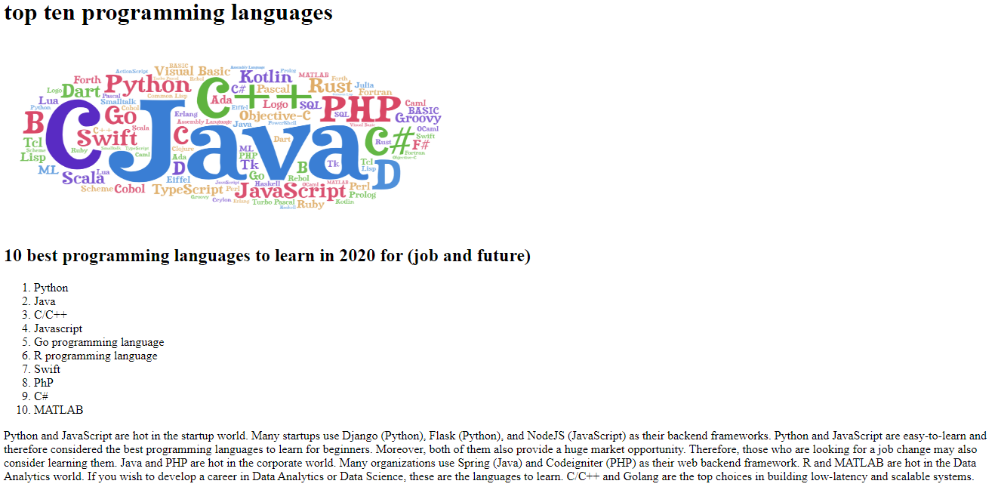

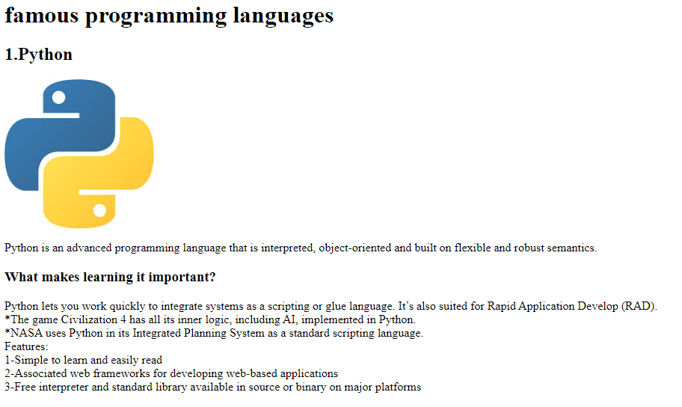

**source code**

